

Chemistry ATAR 3+4

Chemical Equilibrium Test

DO NOT MARK THIS PAPER

TOTAL 52 Marks

Please use the Multiple answer sheet for part 1 and the answer booklet for part 2.

PART 1 : Multiple Choice (12 Marks)

- Which one of the following would NOT cause an increase in the RATE of a chemical reaction?

a) Addition of a catalyst.
b) Increasing the concentration of the reactants.
c) Decreasing the temperature of the reacting species.
d) Increasing the pressure of gases involved in a reaction.

- The decomposition of hydrogen peroxide into oxygen and water proceeds very slowly at room temperature. However, the addition of a small amount of manganese dioxide (MnO₂), causes the hydrogen peroxide to bubble vigorously due to the rapid production of oxygen.

2H₂O_{2(aq)} 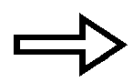 O_{2(g)} + 2H₂O_{(l)} very slow

2H₂O_{2(aq)} O_{2(g)} + 2H₂O_{(l)} vigorous

The best explanation for this is

a) The manganese dioxide acts as a catalyst, providing an alternative reaction pathway that has a lower activation energy.
b) The manganese dioxide increases the temperature of the reaction thereby increasing the collision rate of the molecules.
c) The manganese dioxide increases the collision rate between reacting molecules simply by causing an increase in the total number of molecules in the solution.
d) The manganese dioxide increases the collision energy of the hydrogen peroxide molecules

- The following diagram shows the changes in Potential Energy for the reaction:

N_{2(g)} + O_{2(g)}  2NO_{(g)}
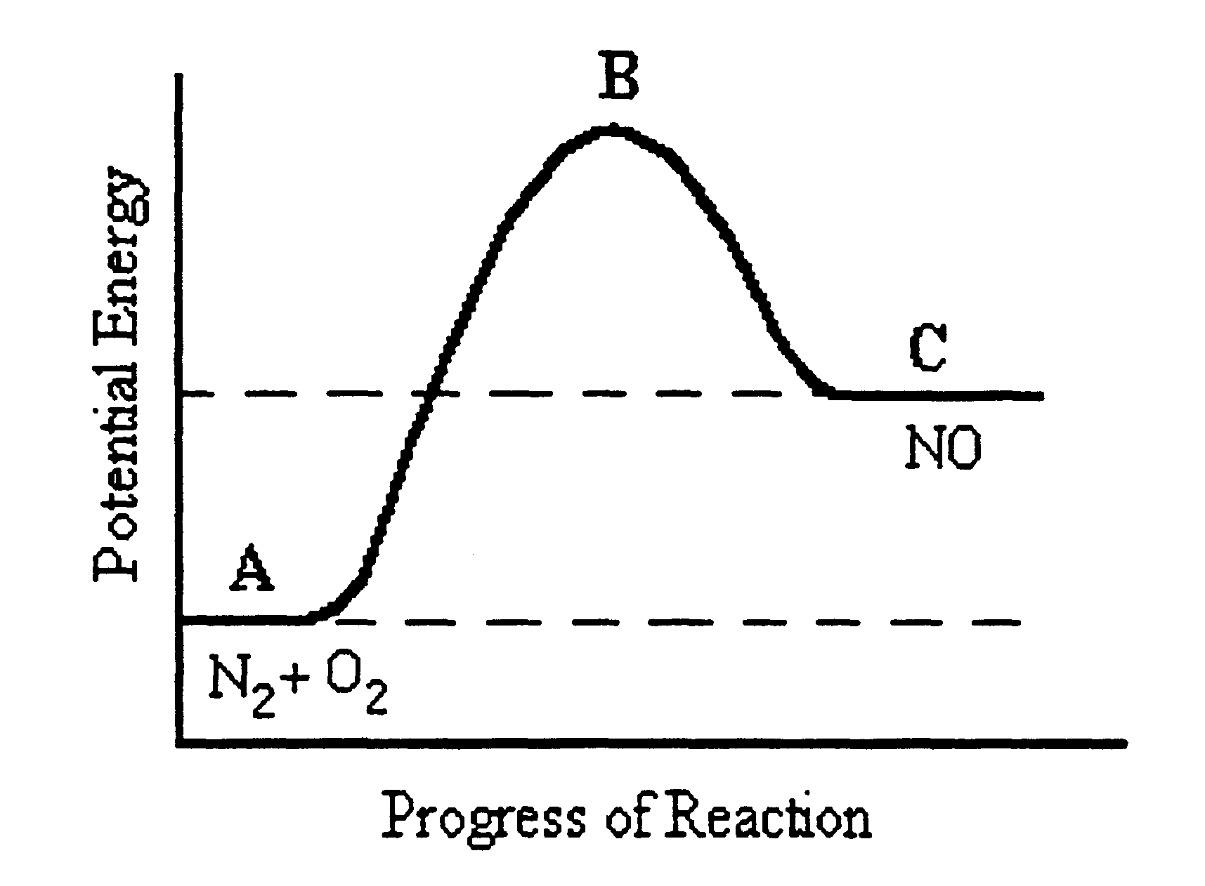

Which of the following statements is FALSE?
a) The reaction is endothermic with ΔH = C – A.
b) The reactants have less potential energy than the products.
c) B represents the transitional state where intermediate compounds are formed in the course of the reaction.
d) The activation energy would be equal to B – C.

- Consider the reaction between marble chips (calcium carbonate) and dilute hydrochloric acid:

CaCO_{3(s)} + 2H⁺_{(aq)}  Ca²⁺_{(aq)} + CO_{2(g)} + H₂O_{(l)}

Which one of the following would increase the rate at which the marble chips react?

a) Decreasing the concentration of the hydrochloric acid.
b) Adding more water to the solution.
c) Crushing the marble chips into powder form.
d) Decreasing the temperature of the acid solution added.

The next question refers to the information below.

An experiment was performed to measure the amount of oxygen gas evolved at ten second intervals, when 40 mL of hydrogen peroxide was allowed to decompose according to the equation:
_{MnO2}
2H₂O_{2(l)} 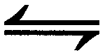 2H₂O _{(l)} + O_{2(g)}

The reaction was carried out at 20ºC and 0.5 g of manganese dioxide added at the start of the experiment. The results are shown in the graph below.
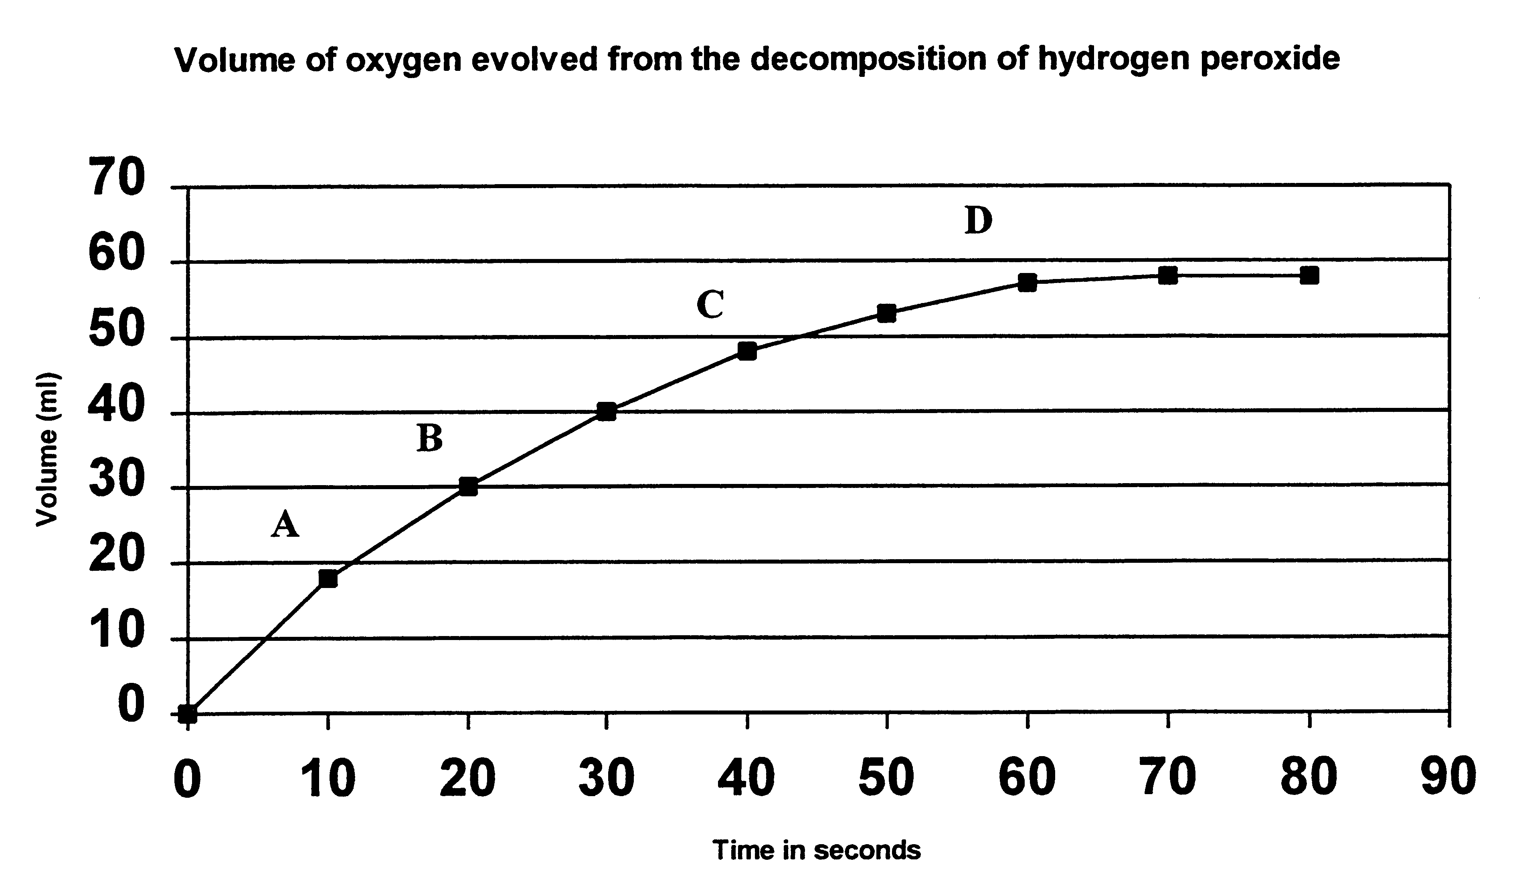

- At what interval is the RATE of reaction greatest?

a) Between 0 and A.
b) Between A and B.
c) Between B and C.
d) Between C and D.

- Consider the following reaction at equilibrium at 1000ºC:

2CO_{(g)} + O_{2(g)} <==> 2CO_{2(g)} ΔH = -556 kJ

Which of the following changes would NOT result in a larger yield of CO₂?

(a) Decreasing the volume
(b) Decreasing the temperature
(c) Adding a catalyst
(d) Increasing the partial pressure of CO(g)

- Which is the correct equilibrium constant for the reaction described in the previous question?

(a) K = [CO₂]
[CO][O₂]

(b) K = [CO]²[O₂]
[CO₂]

(c) K = [CO][O₂]
[CO₂]

(d) K = [CO₂]²
[CO]²[O₂]

- Given the following reaction at equilibrium:

CaCO_{3(s)} + 2HCl_{(aq)} <==> CaCl_{2(aq)} + H₂O_{(l)} + CO_{2(g)}

Which is the correct equilibrium constant for the reaction?

(a) K = [CaCO₃] [HCl]²
[CaCl₂][CO₂] [H₂O]

(b) K = [CO₂] [H₂O] [CaCl₂]
[CaCO₃] [HCl]²

(c) K = [CaCl₂] [CO₂]
[HCl]²

(d) K = [CaCl₂] [CO₂]
[HCl]² [CaCO₃]

THE NEXT TWO QUESTIONS REFER TO THE FOLLOWING REACTION:

4HCl_{(g)} + O_{2(g)} <==> 2H₂O_{(g)} + 2Cl_{2(g)} ΔH = +113 kJ

- To speed up the above reaction, we could:

(a) Increase the pressure
(b) Increase the temperature
(c) Add a catalyst
(d) All of the above

- In order to increase the yield of chlorine, we could:

(a) Decrease the pressure
(b) Decrease the temperature
(c) Add more oxygen to the system
(d) Add more water vapour

- A firm wishes to make industrial use of the equilibrium:

2CO_{(g)} + 2F_{2(g)} + CCl_{4(g)} <==> CF_{4(g)} + 2COCl_{2(g)} + heat

Which set of conditions offers most chance of commercial success?

(a) High pressure, low temperature
(b) High pressure, high temperature
(c) Low pressure, high temperature
(d) Low pressure, low temperature

- The following reaction is allowed to reach equilibrium.

2CrO_{4(aq)} + 2H⁺_{(aq)} <==> Cr₂O₇⁻_{(aq)} + H₂O_{(l)}
yellow orange

If some white powdered Potassium Hydroxide is added what is the observation:

(a) Deeper orange solution
(b) Deeper yellow solution
(c) No change in colour.
(d) Solution turns colourless

PART 2 : Short Answers (40 Marks)

- (a) Sketch and label a reaction profile for the chemical reaction shown below

Sketch the graph to scale. The activation energy is 230kJ mol-1.

H₂ _{(g)} + F₂ _{(g)} 2 HF _{(g)} ΔH = - 540 kJ mol-1

- The overall change in heat energy describes this reaction as
an reaction.
(5 marks)

- In the reaction of a fuel cell a platinum catalyst is used.

2H₂ _{(g)} + O₂ _{(g)} 2 H₂O _{(l)}

- Copy the graph below and show the effect of the catalyst on the energy necessary for the reaction to occur, label E_{a cat}.

- On the graph, show the effect of increasing the temperature of the system (label this T₂).

(2 marks)

- Nitrogen dioxide, NO₂, is a dark brown gas which exists in a state of chemical equilibrium with the colourless gas dinitrogen tetroxide, N₂O₄.

N₂O_{4(g)} <==> 2NO_{2(g)} ΔH = +58 kJ

At 25ºC a sample of the gases at equilibrium is amber coloured.

- If the temperature is raised to 50ºC, predict the change in colour of the sample.

(1 mark)

- Explain, using le Chatelier’s Principle, why this colour change has occurred.

(2 mark)

- Predict what colour change would occur, if any, if the temperature was maintained at 25ºC while the volume of the container was halved.

(1 mark)

- One step in the synthesis of nitric acid from ammonia involves the following reversible reaction.

2NO_{(g)} + O_{2(g)} <==> 2NO_{2(g)} ΔH = -114 kJ

Assume this reaction has reached equilibrium in a closed container at constant temperature and pressure.

- What happens to the equilibrium yield of NO₂(g) if the following occur?
(INCREASE, SAME, DECREASE)

(i) The volume of the container is increased.
(ii) More oxygen is added to the container.
(iii) A suitable catalyst is added.
(3 marks)

- What happens initially to the RATE of the FORWARD reaction if the following changes are made?
(INCREASES, SAME, DECREASE)

- The temperature of the container is increased.
(ii) More NO₂(g) is added to the container.
(iii) A suitable catalyst is added to the container.
(3 marks)

5. Consider the reaction

2SO_{2(g)} + O_{2(g)} 2SO_{3(g)} ; ∆H= -197kJ

(a) Predict the effect that the following imposed changes would have on the position of equilibrium and concentration of all substances. Explain your answer in terms of Le Chatelier’s principle.

NB: Two or three sentences are required for each part.

(i) Pressure is increased.
(ii) Temperature is increased.
(iii) Volume is increased.
(iv) A catalyst is introduced.
[8 marks]

(b) Predict the effect on the value of K if the following changes were made and the reaction attains dynamic equilibrium:

NB: No explanation is required.

(i) Pressure is increased.
(ii) Temperature is increased.
(iii) Volume is increased.
(iv) A catalyst is introduced.

[2 marks]

6. Consider the system: N_{2(g)} + 3H_{2(g)} 2NH_{3(g)}; ∆H = - 92 kJ mol⁻¹

(a) AFTER equilibrium has been established, what effect would the following changes have on the yield of ammonia?

NB: No detailed explanation required.

(i) Decreasing the pressure.
(ii) Decreasing the temperature.
(iii) Using a catalyst.

(b) BEFORE equilibrium is established, what effect would the following changes have on the rate of attainment of equilibrium?

NB: No detailed explanation required.

(i) Increasing the pressure.
(ii) Increasing the temperature.
(iii) Removing the catalyst.

[6 marks]

7. Concentrations of the three substances in the reaction system:

POCl_{3(g)} POCl_{(g)} + Cl_{2(g)}

are shown in the graph below.

- What substance, or substances, was/were initially introduced into the reaction flask at the beginning of the experiment?

- What is shown by the horizontal section of the graphs between 5 and 10 minutes?

- Suggest what might have been done to the system at the 10 minute mark.

- Suggest what might have been done to the system at 15 minutes.

- In which direction did the equilibrium position move to again reach equilibrium after the change at 15 minutes?

- If a catalyst was added at 23 minutes, in what way would the graphs change? Justify your answer.
(7marks)

End of test

